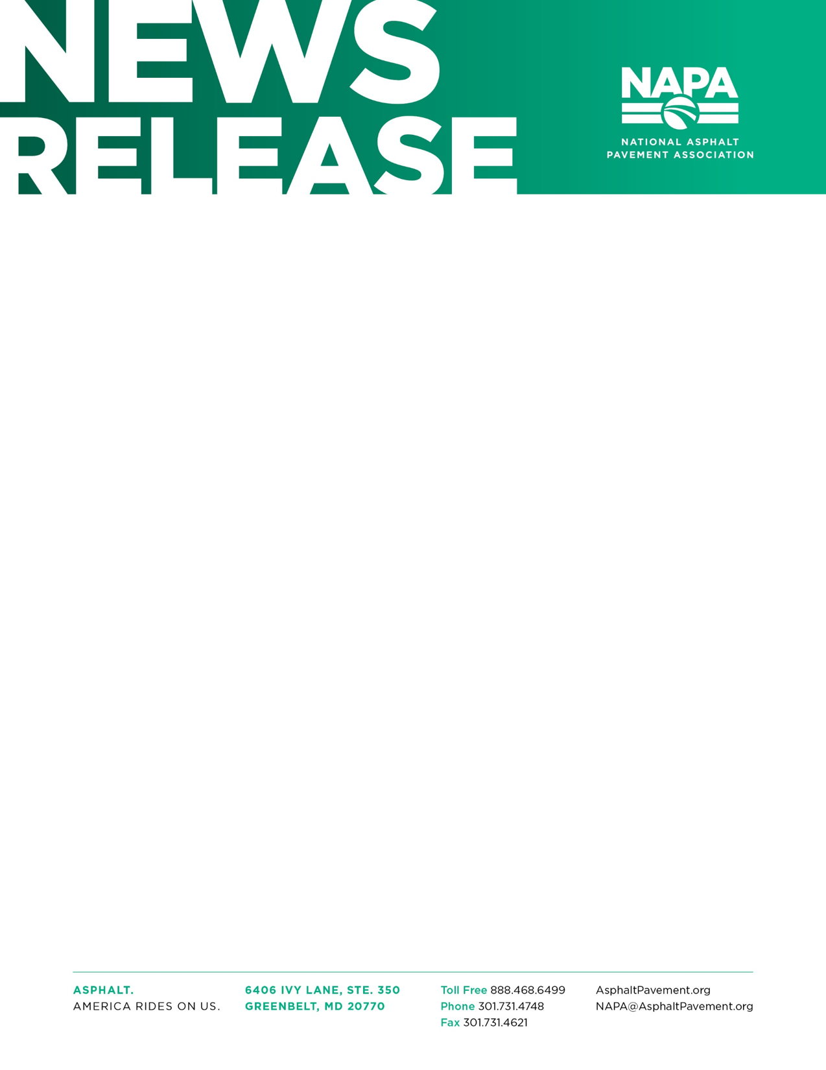

EMBARGOED UNTIL FOR MORE INFORMATION, CONTACT
10:00 AM EASTERN TIME Michelle Kirk, Manager, Alliances & Awards
February 8, 2023 (888) 468-6499 or mkirk@asphaltpavement.org
Eva Hornak for S.T. Wooten Corp.
(919) 612-1123 or Eva.Hornak@stwcorp.com

S.T. WOOTEN CORP. WINS NATIONAL AIRPORT PAVING AWARD

MCAS Cherry Point Airfield Named 2022’s Highest Quality Airport Pavement

GREENBELT, MD—The National Asphalt Pavement Association (NAPA) announced S.T. Wooten Corp. of Wilson, N.C., as winner of the 2022 Ray Brown Airport Pavement Award for excellence in construction of an asphalt pavement. S.T. Wooten Corp. was recognized today at a ceremony during NAPA’s 2023 Annual Meeting in Miami Beach, Fla.

“The asphalt pavement industry is committed to building high-quality projects that deliver superior performance to the traveling public. All contractors’ projects earning a Quality in Construction award are measured against best practices designed to live up to that commitment,” said 2022 NAPA Chairman of the Board James A. Mitchell. “Earning the Ray Brown Airport Pavement Award demonstrates that S.T. Wooten Corp. has met or exceeded these rigorous standards.”

S.T. Wooten Corp. won the award for the MCAS Cherry Point Airfield repair project in Havelock, N.C. The company paved two runways at Cherry Point with an asphalt paver with a vibratory screed. A portable asphalt plant was erected on site to facilitate efficient hauling of the mix to the paver and to improve mix temperature retention. Wooten saw-cut the cold longitudinal joints to vertical and applied tack before placing the adjacent lane. A material transfer vehicle ensured a smooth pavement was placed without mix or temperature segregation. S.T. Wooten used non-tracking tack during paving to avoid causing foreign object debris damage to the aircraft using adjacent runways and taxiways. This type of tack also prevents the pickup of mix or aggregate by paving equipment.

The award is named in honor of Ray Brown, retired Director (1991-2007) of the National Center for Asphalt Technology (NCAT) at Auburn University. Under Brown’s guidance, NCAT became renowned for its asphalt pavement research. The award is presented to the highest scoring Quality in Construction – Airport Pavement project.

###

About NAPA
The National Asphalt Pavement Association (NAPA) is the only trade association that exclusively represents the interests of the asphalt producer/contractor on the national level with Congress, government agencies, and other national trade and business organizations. NAPA supports an active research program designed to improve the quality of asphalt pavements and paving techniques used in the construction of roads, streets, highways, parking lots, airports, and environmental and recreational facilities. The association provides technical, educational, and marketing materials and information to its members; supplies product information to users and specifiers of paving materials; and conducts training courses. The association, which counts more than 1,100 companies as members, was founded in 1955.

